Project Planning Phase
Project Planning Template (Product Backlog, Sprint Planning, Stories, Story points)
Date | 29 September 2026
Team ID | SWTID-2026-7644
Project Name | Script-Controlled ACL – Restrict Record Access Based on Field Value
Maximum Marks | 5 Marks
Product Backlog, Sprint Schedule, and Estimation (4 Marks)
Use the below template to create product backlog and sprint schedule
Sprint | Functional  Requirement (Epic) | User Story  Number | User Story / Task | Story Points | Priority | Team  Members
Sprint-1 | Access Control Setup | USN-1 | As an administrator, I can define the record field used for access control. | 2 | High | Project Team
Sprint-1 | Access Control Setup | USN-2 | As an administrator, I can configure permitted field values for users or roles. | 3 | High | Project Team
Sprint-1 | Script-Controlled ACL | USN-3 | As an administrator, I can create a scripted ACL condition for record access. | 5 | High | Project Team
Sprint-1 | Script-Controlled ACL | USN-4 | As a user, I can access a record when the configured field value matches my permission. | 3 | High | Project Team
Sprint-2 | Access Validation | USN-5 | As a user, I am denied access when the record field value does not satisfy the ACL condition. | 3 | High | Project Team
Sprint-2 | Testing & Audit | USN-6 | As an administrator, I can test allowed and denied field-value scenarios. | 3 | Medium | Project Team
Sprint-2 | Testing & Audit | USN-7 | As an administrator, I can review access decisions for troubleshooting and audit. | 2 | Medium | Project Team
Sprint-2 | Maintenance & Demo | USN-8 | As an administrator, I can update field-based access rules when requirements change. | 3 | Medium | Project Team
Sprint-2 | Maintenance & Demo | USN-9 | As a project owner, I can verify the solution through documentation and demonstration. | 2 | Low | Project Team

Story Point Scale
1 – Very Easy task 2 – Normal task 3 – Moderate task 5 – Difficult task

Project Tracker, Velocity & Burndown Chart (4 Marks)
Sprint | Total Story  Points | Duration | Sprint Start Date | Sprint End Date  (Planned) | Story Points  Completed (as on  Planned End Date) | Sprint Release Date  (Actual)
Sprint-1 | 19 | 1 Day | 29 Sep 2026 | 29 Sep 2026 | 19 | 29 Sep 2026
Sprint-2 | 18 | 1 Day | 30 Sep 2026 | 30 Sep 2026 | 18 | 30 Sep 2026
Velocity:
The planned team velocity is calculated from the total story points completed across the two sprints.
Average Velocity = Total Story Points / Number of Sprints = 37 / 2 = 18.5 Story Points per Sprint
Burndown Chart:
A burndown chart is a graphical representation of work left to do versus time. It can be used to track remaining story points during the sprint schedule.
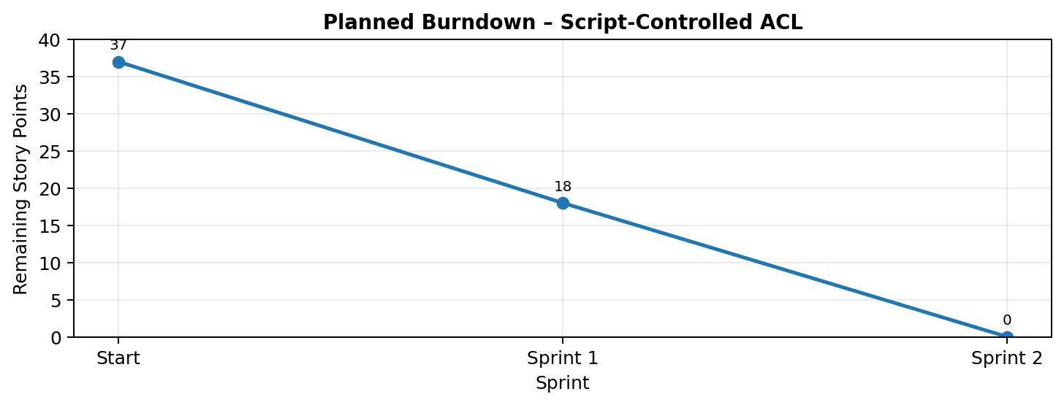

Sprint Planning – Story Point Summary
Project: Script-Controlled ACL – Restrict Record Access Based on Field Value
Sprint | Epic | Story | Task | Story Points
Sprint-1 | Access Control Setup | USN-1 | Define record field for access control | 2
Sprint-1 | Access Control Setup | USN-2 | Configure permitted field values | 3
Sprint-1 | Script-Controlled ACL | USN-3 | Create scripted ACL condition | 5
Sprint-1 | Script-Controlled ACL | USN-4 | Allow access when field value matches | 3
Sprint-1
Sprint-1 Total |  |  |  | 13
Sprint-2 | Access Validation | USN-5 | Deny access when field value does not match | 3
Sprint-2 | Testing & Audit | USN-6 | Test allowed and denied scenarios | 3
Sprint-2 | Testing & Audit | USN-7 | Review access decisions for audit | 2
Sprint-2 | Maintenance & Demo | USN-8 | Update field-based access rules | 3
Sprint-2 | Maintenance & Demo | USN-9 | Verify documentation and demonstration | 2
Sprint-2 Total |  |  |  | 13

Story Point Calculation
Sprint 1 story points = 2 + 3 + 5 + 3 = 13
Sprint 2 story points = 3 + 3 + 2 + 3 + 2 = 13
Total planned story points = 13 + 13 = 26
Velocity
Velocity = Total completed story points / Number of sprints
Velocity = 26 / 2 = 13 Story Points per Sprint
The planned team velocity is 13 Story Points per Sprint.
Sprint Completion Criteria
• ACL conditions evaluate the configured field value at the time of the request.
• Authorized users receive the requested record when the rule condition is satisfied.
• Unauthorized users are blocked without exposing protected record information.
• Scripts and ACL conditions remain testable, maintainable and auditable.

References
https://www.atlassian.com/agile/project-management
https://www.atlassian.com/agile/tutorials/sprints
https://www.atlassian.com/agile/tutorials/epics
https://www.atlassian.com/agile/project-management/estimation
https://www.atlassian.com/agile/tutorials/burndown-charts
Project Planning Notes
The sprint schedule is structured around the field-value ACL implementation: configuration, scripted access evaluation, validation, auditing, maintenance and demonstration.
Story points use the requested Fibonacci-style scale of 1, 2, 3 and 5. The planned backlog contains 26 story points across two sprints.
Team ID: SWTID-2026-7644
Project: Script-Controlled ACL – Restrict Record Access Based on Field Value

